MUNAZA MUNIR – 03220147287 – 70146760@student.uol.edu.pk

Session 3 – Task 5

Appium Mobile Automation Introduction Report

1. Objective
The objective of this task was to gain introductory experience with Appium, an open-source mobile automation testing framework. The task involved setting up the Appium testing environment, preparing an Android emulator, understanding the basic workflow of mobile automation, and creating a simple automation script to interact with a mobile application or browser.

2. Tools and Technologies Used
Tool | Purpose
Visual Studio Code | Code editor
Node.js | JavaScript runtime environment
NPM | Package manager for installing Appium
Appium | Mobile automation framework
Android Studio | Android development environment
Android Emulator | Virtual Android device
Google Chrome (Android) | Mobile browser used for testing
JavaScript | Automation scripting language

3. Software Requirements
The following software was installed before beginning mobile automation:
- Node.js
- NPM
- Appium
- Android Studio
- Android SDK
- Android Virtual Device (AVD)
- Google Chrome (Android Emulator)
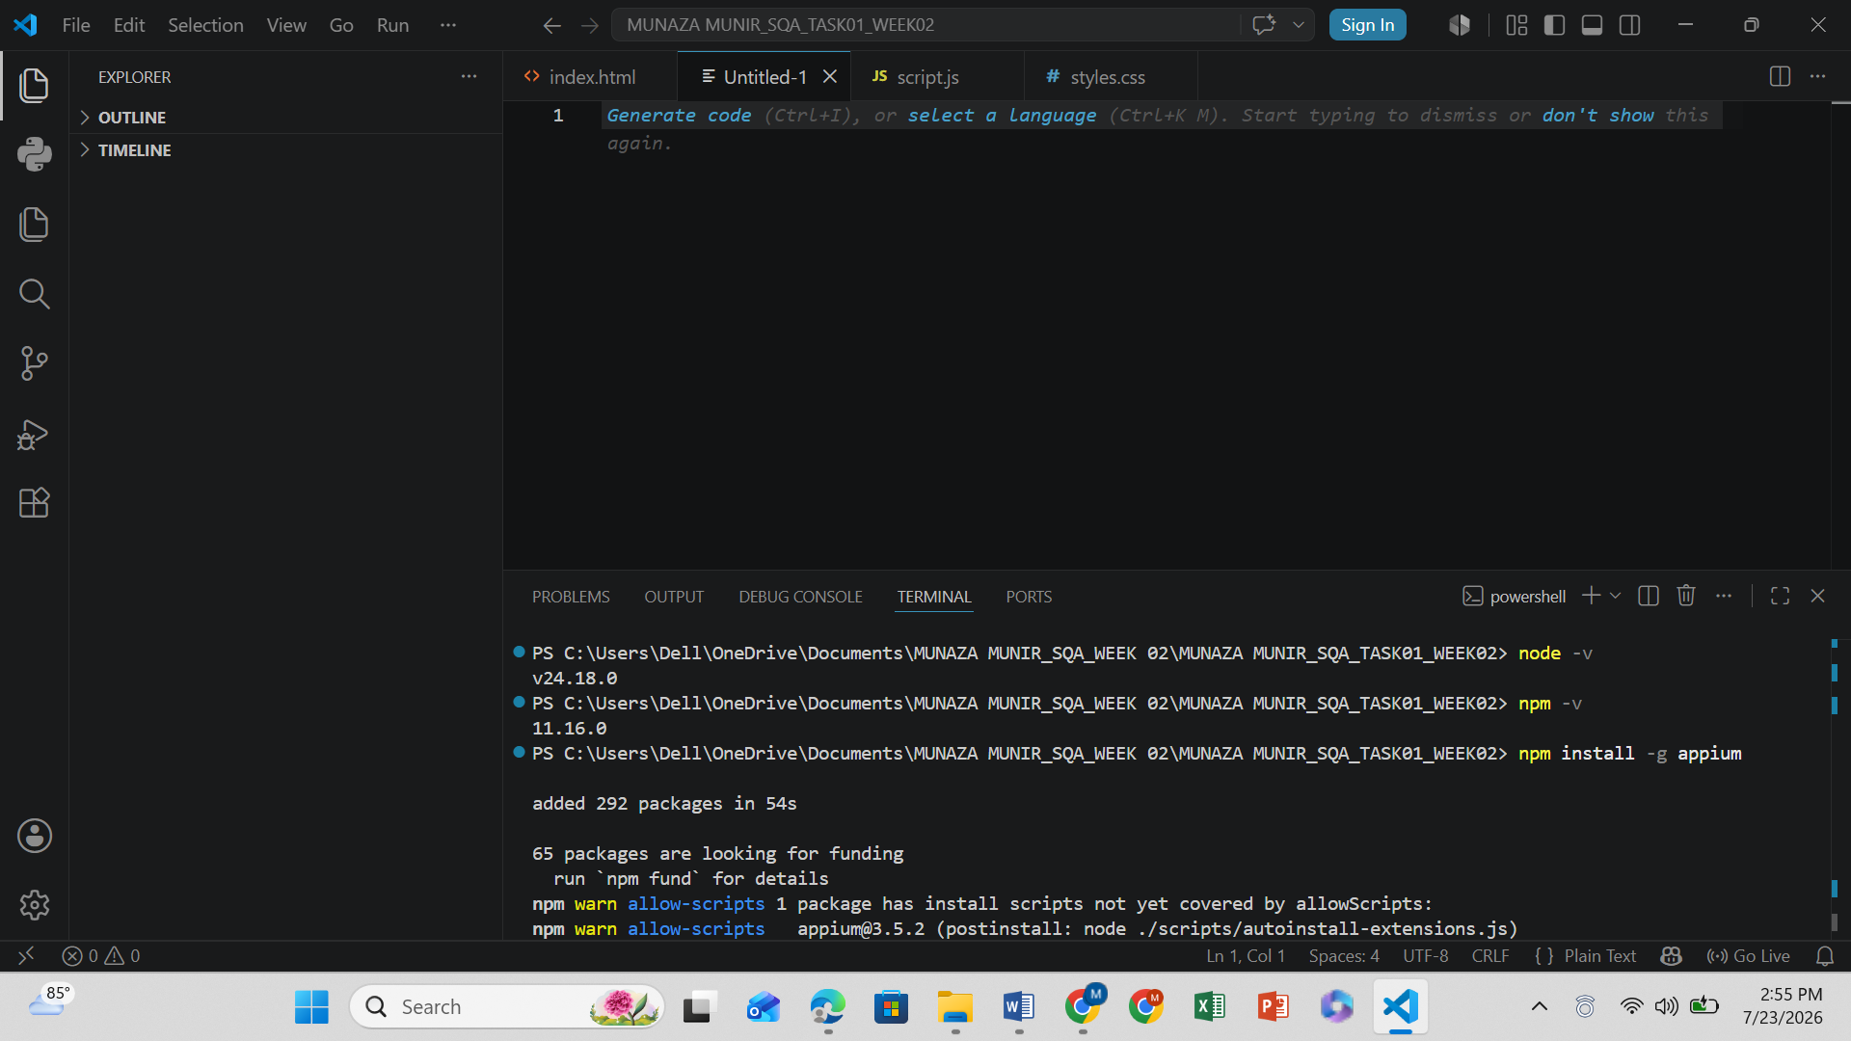
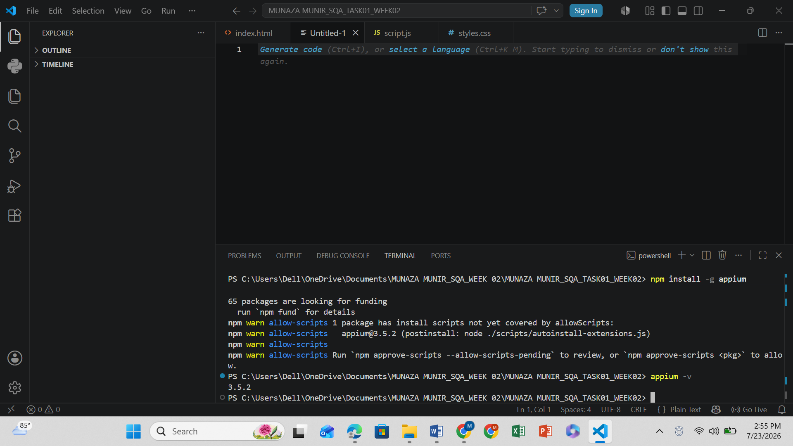

4. Installation Process
The following steps were completed to prepare the Appium testing environment:
- Installed Node.js and verified the installation.
- Installed Appium globally using NPM.
- Verified the Appium installation.
- Installed Android Studio.
- Downloaded the Android SDK and required components.
- Created an Android Virtual Device (AVD).
- Started the Android emulator.
- Connected Appium with the Android emulator.

5. Appium Installation
Appium was installed globally using the following command:
npm install -g appium
The installation was verified using:
appium -v
The successful version output confirmed that Appium was installed correctly.

6. Android Emulator Setup
An Android Virtual Device (AVD) was created using Android Studio.
The emulator configuration included:
- Device: Pixel Emulator
- Operating System: Android
- Browser: Google Chrome
The emulator was launched successfully and was ready for automation testing.

7. Test Scenario

Scenario
Open Mobile Browser and Enter Text

Objective
To verify that Appium can successfully launch the Android mobile browser, interact with UI elements, enter text, and validate the expected screen.

Test Steps
- Launch the Android emulator.
- Start the Appium server.
- Connect Appium with the emulator.
- Open the Chrome browser.
- Locate the search/address bar.
- Enter sample text.
- Perform the search.
- Verify that the search results page is displayed.
- Close the browser session.

8. Automation Features Used
The following Appium actions were performed:
- Launch application
- Locate UI elements
- Tap an element
- Enter text
- Verify screen content
- Close the session

9. Sample Automation Script
A basic Appium automation script was prepared to understand the workflow of mobile automation and browser interaction.
The script demonstrated:
- Starting an Appium session
- Opening the mobile browser
- Entering text
- Performing basic verification
- Ending the automation session

10. Expected Result
The automation should:
- Successfully connect to the Android emulator.
- Launch the mobile browser.
- Enter the specified text.
- Display the expected screen or search results.
- Complete the automation without errors.

11. Test Result
Test Scenario | Description | Status
Mobile Browser Automation | Launch browser, enter text, and verify result | PASS

12. Learning Outcomes
During this practical activity, the following concepts were learned:
- Introduction to Appium
- Mobile automation testing
- Installing Appium using NPM
- Android Studio setup
- Android Emulator configuration
- Connecting Appium with an Android device
- Automating mobile browser interactions
- Understanding Appium workflow
- Writing basic mobile automation scripts

13. Advantages of Appium
- Supports Android and iOS automation.
- Open-source and free to use.
- Works with multiple programming languages.
- Reuses Selenium WebDriver concepts.
- Supports real devices and emulators.
- Widely used for mobile application testing.

14. Conclusion
This introductory task provided practical exposure to mobile automation testing using Appium. The testing environment was configured by installing Appium, Android Studio, and an Android emulator. A basic automation scenario was implemented to interact with the mobile browser by launching the application, entering text, and verifying the expected result. This activity introduced the core concepts of mobile automation and demonstrated how Appium can be used to automate Android applications and mobile browsers efficiently. The task served as a strong foundation for learning advanced mobile application testing techniques in future projects.

